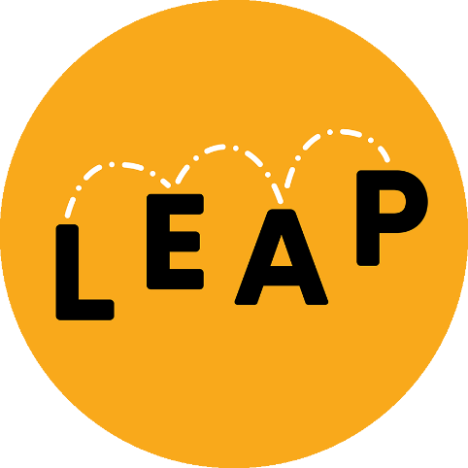

WHO WE ARE
Set up in 2015, Lambeth Early Action Partnership (LEAP) is made up of parents, early years practitioners, nurseries, children’s centres, the National Children’s Bureau, Lambeth Council, NHS trusts, community organisations and several local charities.

WHAT IS LEAP?
Our primary aims are to:
- Give thousands of children aged 0-3 years a better start in Coldharbour, Stockwell, Tulse Hill, and Vassall.
- Use LEAP’s learning and evidence to positively influence early years services across Lambeth and beyond.
LEAP aims to do this by demonstrating how children’s life chances can be improved through a combination of enhanced early years investment and from knitting local services together through a multi-agency partnership.
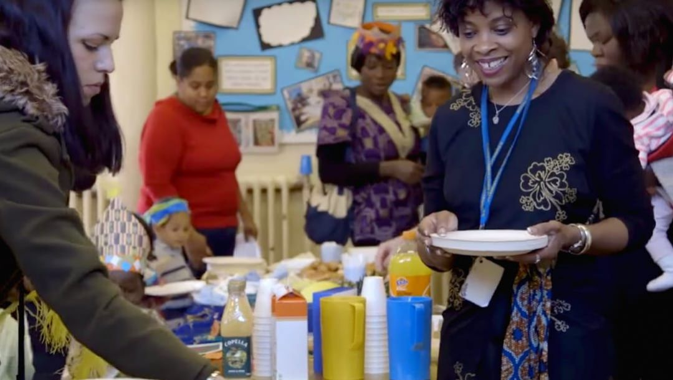

WHO IS LEAP FOR AND WHY?
The earliest years of a child’s life are an especially vital time, when brains develop rapidly and foundations are laid for the future. To capitalise on this, and to learn about which types of early years services are most effective, LEAP works exclusively with pregnant women and children aged 0-3 years and their families.
LEAP delivers services across our four target wards of Coldharbour, Stockwell, Tulse Hill, and Vassall. By focusing on this defined area and population, we can deliver a wide range of early years supports and test what difference it is possible to make with this level of activity.
You can find out if you are eligible for LEAP services on our postcode checker. If you are not, we can refer you on to wider services.

WHAT DOES LEAP DO?
In our target wards, LEAP fund, continuously improve, and evaluate over 20 services. These fall into two groups:
- Services that work directly with children to help them reach their developmental milestones.
- Services that support children indirectly, by working with parents, early years practitioners, and the wider community, so they are better equipped to provide the responsive relationships and positive experiences that children need.
LEAP is a ‘collective impact initiative’, which means that all our services and activities link together and work towards shared goals around improving children’s outcomes.
Also, LEAP shares learning and evidence beyond our target wards with early years experts and policymakers. This is so our learnings and findings can be incorporated into their work, to make an impact beyond Lambeth.

HOW DOES LEAP SUPPORT BABIES, CHILDREN AND FAMILIES?
LEAP services support families at every step through pregnancy and the early stages of a child’s life.
Given that many different aspects of children’s development are related, we work across three strands encompassing children’s:
- diet and nutrition,
- social and emotional well-being,
- communication and language.
These strands are important because services focused on just one of these strands could be undermined by challenges from one of the other strands (for instance, a child’s poor emotional well-being could impact on their language and communication). Working simultaneously across all three strands gives us a greater chance of making a positive and lasting impact on children and families.
Each LEAP service fits within one of these three strands. However, they also contribute to broader goals that cut across the strands.
For example:
- Supporting you and your family through your pregnancy journey (Caseload Midwifery, Group Pregnancy Care, Community Activity and Nutrition, Baby Steps).
- Giving your child a healthy start (Community Activity and Nutrition, Breastfeeding Peer Support, Community Nutrition, Healthy Living Platform, Oral Health Support Service).
- Bonding with your baby and enjoying quality time together (Baby Steps, Family Nurse Partnership, Parent and Infant Relationship Service, Empowering Parents Empowering Communities).
- Supporting you to help develop your child’s early language and communication (Chattertime, Raising Early Achievement in Literacy, Sharing REAL with Parents, Doorstep Library).
- Bringing parents together so they can share knowledge on local services and how best to support children’s development (Parent Champions, Community Engagement, Community Awards).
- Supporting you and your family to minimise the amount of stress you are under (Overcrowded Housing Support Service, Domestic Violence Support Service).

HOW IS LEAP FUNDED?
LEAP received £36 million from the National Lottery Community Fund as part of the national A Better Start programme. Under the agreement, the National Children’s Bureau became the accountable body for this funding and the host for the LEAP Partnership.

HOW IS LEAP GOVERNED?
LEAP is governed through a Partnership Board comprised of parents, senior members of the LEAP core team, and representatives from local agencies and organisations.
The Partnership Board is jointly chaired by the Chief Executive of the National Children’s Bureau, Anna Feuchtwang, and Lambeth Council’s Strategic Director of Children’s Services, Annie Hudson.
Each board meeting starts with a report from the LEAP Director Laura McFarlane and LEAP’s Parent Representatives who represent the community.

WHAT ABOUT LEAP’S EVALUATION?
Overall, LEAP’s evaluation is focused on understanding our impact and understanding how, why, for whom, and under what circumstances this impact has taken place.
The aims of the evaluation are:
- To demonstrate the achievements of our individual services in improving early childhood development.
- To show how our portfolio of services and ways of working complement and work in combination with one another to make a greater difference for children and families.
Often at LEAP services and events you may be asked to provide information or complete a survey. This is vital to help us get a better view of the needs of the area and the effects of our work.

